**Identifying the Most Important Problems in Latin American Countries – Based on Citizens’ Perceptions**

Report for the Applied Data Science Capstone project

Author: JUAN MARTINEZ

Date: 25/01/2021

**Purpose of the project**

This project's aim is to explore what are the Latin American citizens' views on what constitutes the most important problems in their countries. Latin American countries, as any other country in the world, have their particular issues that citizens deal with and which affect their development. Because of plenty of characteristics shared by Latin American communities, groups of countries in the region have common problems. By identifying these problems, we can more accurately advice on the adequate policy interventions that would improve the conditions of living in each subregion[1] of the study.

The results and conclusions of this work might be of interest specially to governments, policymakers, and other agents with the power to influence the destiny of each region in the study who are willing to make the contribution.

**Introductionu**

Latin America is home to about 642 million citizens, conformed by countries that share plenty of characteristics: from the colonial past and later independence of most of them; the romance languages, mainly Spanish, except for Brazil, French Guiana and Suriname; similar economic practices, political history and religion; but also, the similarities extend to the problems and challenges that obstruct their development.

These shared characteristics make it possible to look at Latin America as a particular region where patterns repeat within its communities, and this study, by analyzing data on the problems people from the region face, attempts to identify the main problems in the region and define profiles for different subregions that will make it easier for governments and policymakers to determine where and how to act to improve the conditions in each subregion.

**Objectives of the study**

The goals of this project can be summarized in the following three objectives:

1. Identify what are the most important problems Latin American citizens perceive in their respective countries.
2. Find patterns and define clusters for Latin American subregions based on the problems they share, which can make analysis of the living conditions in the region easier and allow us to think about specific policy implementations to improve them, following a strategy of “a measure to fix them all” for all the subregions with similar problems.
3. Assess how the problems reported in each subregion relate to indicators that are relevant to measure the quality of governance, such as trust in the government and institutions and satisfaction with life.

**Methodology**

The goals of this project can be met by means of tools of data analysis. Specifically, the study will follow these steps:

1. Cleaning, processing, and analysis of the data to obtain information on what are the main problems people perceive in their countries, both at the country level and by subregions.
2. Develop the appropriate visualizations to make analysis of the data easier.
3. A KMeans algorithm will be employed to define clusters for each subregion in the study based on the problems people perceive as the most important.
4. Comparisons of clusters’ performance in certain indicators will be carried on through ANCOVA analysis and other analysis of the scores.

**Specifications of the data**

**Source of the data:** All the data to work with is obtained from the Latinobarometro survey of 2018, which gathers data on 20,204 Latin American citizens’ values, perceptions, and opinions on a wide range of topics, of which most are relevant to their daily lives (https://www.latinobarometro.org/latContents.jsp).

After removing observations from subregions with less than 30 observations, the data will cover:

* Number of countries: 18
* Number of subregions: 176 (note that not all the subregions in Latin America are included, only the ones for which there was a sample large enough to make an adequate analysis possible).
* Number of observations: 15825
* Number of observations by country:

|  |  |
| --- | --- |
| **COUNTRY** | **COUNTRY** |
| Argentina | 1049 |
| Bolivia | 1014 |
| Brazil | 871 |
| Chile | 1023 |
| Colombia | 1017 |
| Costa Rica | 929 |
| Ecuador | 917 |
| El Salvador | 843 |
| Guatemala | 590 |
| Honduras | 795 |
| México | 686 |
| Nicaragua | 689 |
| Panamá | 786 |
| Paraguay | 1086 |
| Perú | 894 |
| República Dominicana | 633 |
| Uruguay | 858 |
| Venezuela | 1051 |

Table 1 Number of observations by country

**Variables:** From the survey, diverse variables will be used for the different parts of the analysis. These parts include visualizations, clustering, geospatial visualization, and ANCOVA analysis. Some of the most important variables are:

* Most important problem in the country: responses to the question "most important problem in your county".

For ANCOVA analysis:

* Trust in the government.
* Trust in the institutions (composite of trust in the government, trust in the police, trust in the congress, and trust in the justice system)
* Satisfaction with life.
* Average education level.
* Average socioeconomic status.

Coordinates for geospatial visualization will be obtained from the Nominatim API.

**Analysis of the data**

A good way to start this analysis is by looking at the “big picture”, that is, by answering what are the problems that are considered the most important overall. We do this by looking at the problems that, among the 176 subregions of the study, appear more often as the most important ones.

The figure 1 shows the problems considered the most important ones and in how many subregions of the 176 they are so. The figure 2 shows the second most important problems.

The first thing to notice is that crime / public safety is clearly the most common most important problem, designated that way in over a third of the subregions of the sample. Unemployment and economic / financial problems come second and third, respectively, being the most important problems in over 15% of the subregions of our sample. Corruption and problems related to the political situation appear later, but still are important problems.

It is also interesting although alarming to see how in part of the sample either health problems or scarcity of food is the most important problems, which are problems that refer to very basic needs.

In the figure 2 we see that the five second most important problems are the same of the figure one, although in different order. Which confirms that overall, people perceive that the most important problems in Latin America include crime / public safety, unemployment, economic / financial problems, corruption, and problems related to the political situation.

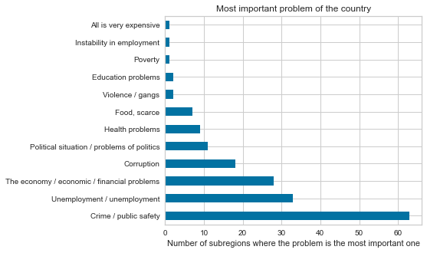

Figure 1 Most important problem in the country by subregions

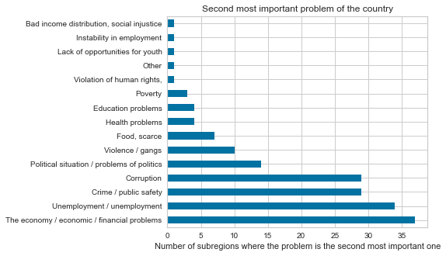

Figure 2 Second most important problem in the country by subregion

Now, although these are the most common problems, it does not mean that in every Latin American country or province the problems are the same. The truth is that each place has its own reality, its own set of problems, and while many parts of Latin America indeed share similar characteristics, for a topic of this kind, it is important to distinguish each place’s specific issues first before attempting to set the objects of the study in groups.

Before looking at how subregions are distinct from each other, I continue with looking at the main problems by country.

Figure 3 and table 1 are about the most important problems by country based on the frequency of the responses from the Latinobarometro survey. While the table shows simply the three most important problems by country, the figure shows the proportions for each problem in the responses.

The results here are very consistent with the results from the previous section. Crime / public safety problems are the most important in over a third of the sample, in fact, in almost a half of the countries. It is followed by unemployment in 4 out of the 18 countries, and then by economic / financial problems in 3 of the countries.

For the second most important problems, corruption and unemployment appear in 5 of the countries each while crime / public safety and economic / financial problems are second most important in 3 countries each. Scarcity of food is in the list only as the second most important problem in Venezuela, and interestingly, this is confirmed by the bar chart by almost a quarter of the respondents declaring that the most important problem in Venezuela is scarcity of food, after economic / financial problems.

As stated before, some kinds of problems can be common across the Latin American region, but not necessarily in the same proportion everywhere. Since the sample taken does not cover all the subregions in every country and each subregion has a different sample size, I acknowledge the graph has its flaws and should not be taken as a perfect indication of what proportions of people think each problem is the most important in their respective countries. But still, the samples of each country are large enough to give us a good approximation of what the actual values would be, specially when some proportions are large enough that are easily distinguishable from others.

That is the case for the problem of scarcity of food in Venezuela mentioned before, and also it is for issues such as crime /public safety, which in countries such as Chile, El Salvador, Dominican Republic and Uruguay is considered the most important one by about 40% of the respondents. Similarly, in no other place problems related to the political situation has such a large share as in Nicaragua, at about 40%. Also, corruption is declared the most important problem by over 20% of the respondents in Colombia and Peru, different from any other country.

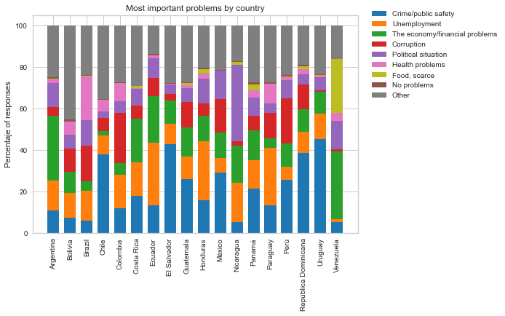

Figure 3 Most important problems by country

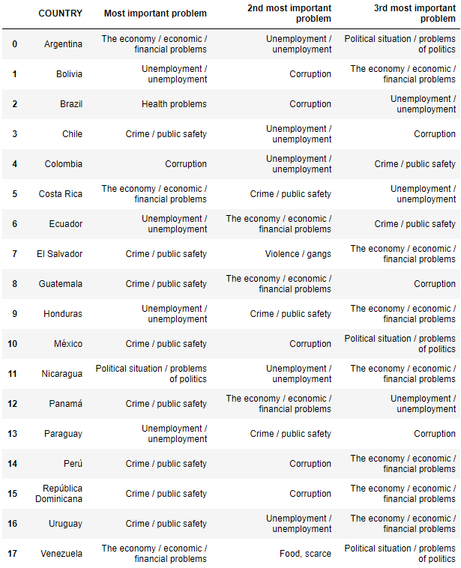

Table 2 Three most important problems by country

After having seen the “big picture”, we can look at the problems in subregions individually. Given that the study covers 176, it is difficult to discuss each one of them here or even look at all the data in this document. Instead, I am sharing a link where you can check freely what are the five most important problems in each subregion of the study, determined by the same methodology of the previous sections.

Download the dataset by clicking [here](https://github.com/Jumarti96/Coursera_Capstone/blob/master/top_5_problems_by_country.xlsx?raw=true).

To simplify the analysis of the problems in the subregions, I developed a KMeans algorithm that put the subregions in 8 clusters based on the most important problems they share. The algorithm groups the subregions based on the similarity of scores assigned to each subregion for each of the important problems proportional to the shares of responses indicating that each specific problem is the most important.

This method also provides interested agents with profiles for each cluster that represent the most important problems that the countries in the cluster share, which can be helpful for developing strategies and policies to intervene and improve the situation in each region. Some suggestions of how policymakers or institutions can take advantage of this data: knowing which subregions are similar and what important problems they have in common, they can develop strategies to cover several subregions at once; also policymakers from different subregions with limited influence will be able to find where else the situation is similar and with whom they could cooperate to share ideas on strategies to intervene, coordinate action plans or simply share information.

Table 3 shows the different clusters and the most important problems shared by the countries in it; each column shows for each cluster the problems that make for at least 70% of the responses found in that position, so that we can say, for example, that for most subregions in the cluster 1, the most important problem was corruption, followed by problems of crime / public safety. Similarly, for the same cluster, the 2nd most important problems that subregions in the cluster have are crime / public safety, for most of the others it is unemployment, and for others the problems are financial, while some subregions in the group might have other problems as their 2nd most important problem but they represent a minority in the cluster.

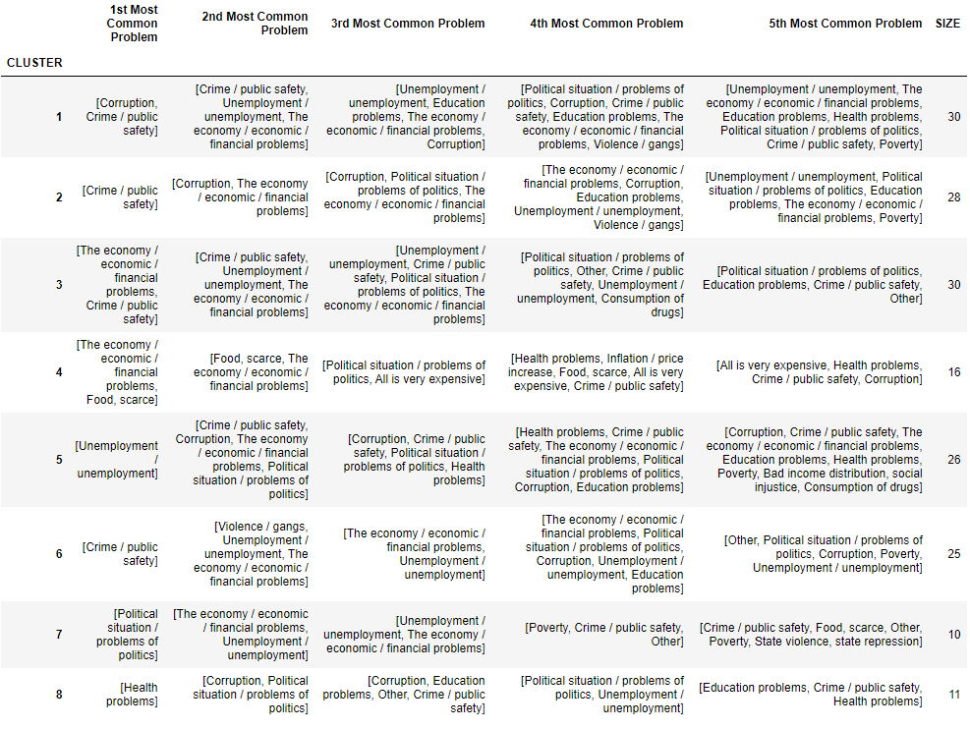

Table 3 Clusters of subregions by most important problems

In figures 4 and 5 we can also see how these clusters are distributed geographically. The maps show Latin America with the subregions of the study as dots of a color representative of their clusters.

What gets most of my attention is how clusters seem to be concentrated in specific countries or in areas within countries. Cluster 4 is exclusive to Venezuela, where with the exception to one subregion all the other subregions are part of the cluster 4, and this is because it is only in Venezuela where scarcity of food is one of the most important problems in most states. In a similar way, the cluster 7 is exclusive to Nicaragua, where for most departments the political situation / problems of politics are the most important, followed by financial problems and unemployment.

For El Salvador, all departments in the study are part of the cluster 6, although subregions in Dominican Republic, Chile, and Uruguay are also part of the cluster. Subregions in this cluster are characterized for crime / public safety as their most important problem, but in comparison with other subregions for which this is the most important problem, the people in subregions of the cluster 6 also consider violence / gangs as a serious problem.

Unfortunately, for a massive country such as Brazil, there are several states not covered in the study, specially in the north and north-west areas of the country, so we might miss some important insights from those areas. But from the information we do have, it seems that cluster 8 is almost exclusive to Brazilian states, except for two departments in Colombia. Most subregions in this cluster have health problems as their most important problem, which is not common in other subregions, and other very important problems are corruption or problems of politics and problems of education or crime.

There are other countries where the clusters are clearly concentrated in areas within the country, such as in Colombia, Ecuador, Mexico, and very likely in Dominican Republic as well. In Colombia, departments located in the Caribbean region are part of the cluster 5, while departments in the center and moving to the west are mostly part of the cluster 1. While for departments in both clusters crime / public safety and unemployment and financial problems are some of the most important problems, for cluster 1 problems of corruption gain relevance while for cluster 5 unemployment is the most important.

In the case of Ecuador, provinces in the central are to the north are classified as part of the cluster 5, while provinces in the south are classified as part of the cluster 3. In Mexico, although several states in the north of the country are not part of the study, we can say with certainty that states in the central part of the country are part of the cluster 2, which is conformed by subregions for which the most important problems are typically crime / public safety, corruption, economic / financial problems, and problems of politics.

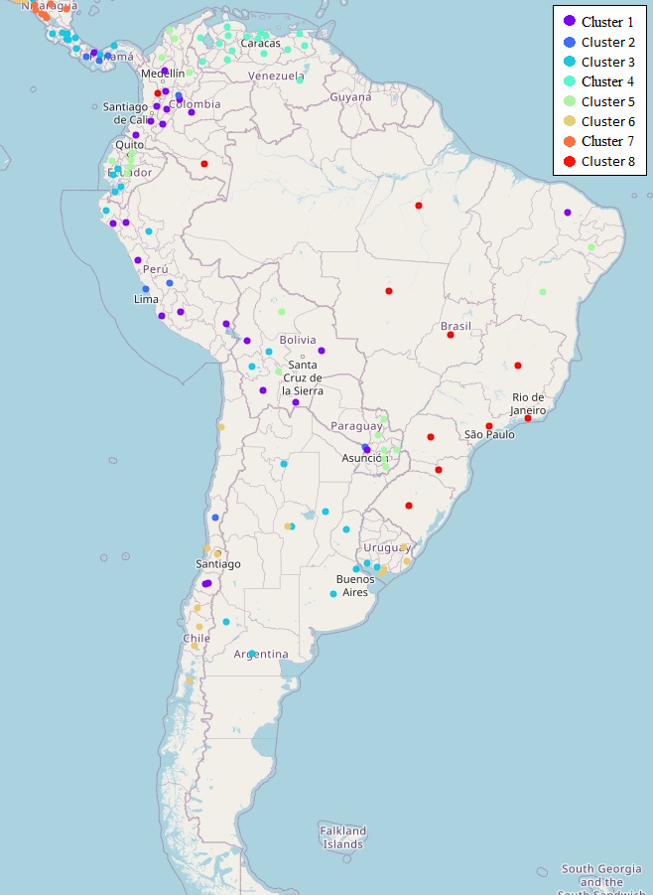

Figure 4 Latin American subregions with clusters indicated by colors - south part.

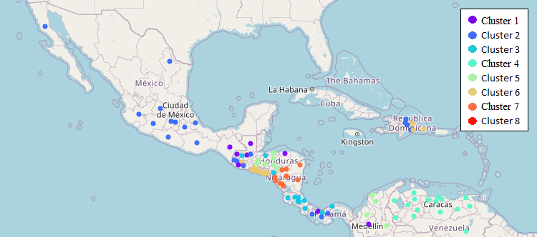

Figure 5 Latin American subregions with clusters indicated by colors - central and north parts.

**Most important problems and other indicators**

For the last part of this study, I consider it useful to look at how the conditions of each of the clusters defined is reflected in other indicators of the quality of life of citizens in the territories or in indicators of the quality of governance. It is helpful to know that are the most important problems that people in each region face, but this information is incomplete if we do not know how serious these problems are, or how they are influencing other indicators.

I admit that assuming that these problems are the direct cause of the performance on the regions in the indicators we are going to examine is not a perfect approach, as correlations do not imply causality. To explore the causality, we should perform a different kind of study that would require more in-depth examination and experimentation which is not among the aims of this project.

However, you can see this as a starting point, to see how different subregions perform in certain indicators and thus see where it is more important to intervene, knowing then what are some of the problems for which intervention is desirable.

This part consists on a comparison of the performance of the clusters on three indicators: trust in the government, trust in the institutions, and satisfaction with life. What I want to show is the differences in the average scores in these indicators as well as how the performances vary in each cluster, remembering that these clusters were defined exclusively on the basis of how similar subregions are with respect to the problems they have.

That will be achieved by means of an ANCOVA analysis for each of the indicators. To get a more accurate idea of the relationship between the performance in the indicators and the important problems in the subregions, two control variables, average level of education and average socioeconomic status of the respondents of each cluster, will be included as covariates, as these variables have the potential to influence the performance in the indicators, so we want to discount their impact on the indicators to analyze.

Before turning to the ANCOVA analysis, I turn to show some context on how the region looks with regards to the indicators we want to see. Figures 6 and 7 show the proportions of responses to the questions: “for each of these groups, institutions or people in the list, how much trust do you have in them? Government” and “in general terms, would you say you are satisfied with life? Would you say you are…?”, respectively.

Speaking of trust in the government, it seems quite low all across Latin America. In all of the 18 countries of the study, over 60% of the respondents reported having low trust or no trust in the government at all, the highest share being in Brazil at around 90% and the lowest in Chile and Dominican Republic at around 61%. For responses of no trust at all the share was the highest in Nicaragua (65%), followed by Venezuela (63%), Brazil (60%), and El Salvador (58%). On the other hand, responses of ‘trust the government a lot” do not surpass 10% in any country. For responses of either “trust a lot” or “some trust” the higher shares are in Chile (39%), Uruguay (38%), Costa Rica, and Bolivia (about 35%).

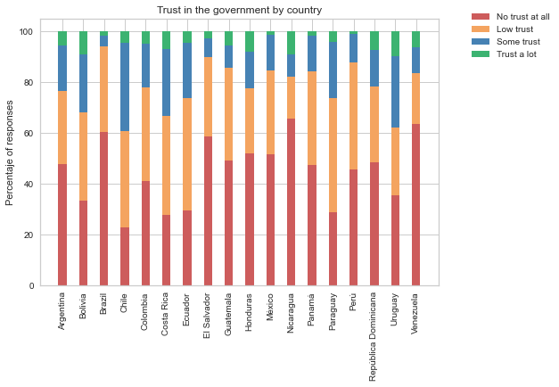

Figure 6 Shares of responses regarding trust in the government by country.

Despite the relatively low levels of trust in the government, figure 7 shows a contrasting landscape for the degree of satisfaction with life. Lower shares of either “very satisfied with life” or “greatly satisfied with life” are around 62% in countries such as Bolivia, Brazil, Nicaragua, and Venezuela, while the highest shares are seen in Colombia, Costa Rica, Guatemala, Panama, and Dominican Republic, between 85% and 90%. Countries where the share of responses of people claiming not to be satisfied with life at all is the highest include, Venezuela (about 15%), Nicaragua (11%), and el Salvador (10%). Interestingly, these countries with the highest shares of people not satisfied at all with life, are the countries where a cluster classification was exclusive to them, except for El Salvador, although all of its provinces fell under the same cluster classification. In the case of Venezuela, remember that it is the only country where scarcity of food, a basic need, was a serious issue in almost all the states that were part of the study. Meanwhile in Nicaragua, it is the country with the clear highest share of respondents preoccupied with problems about the political situation.

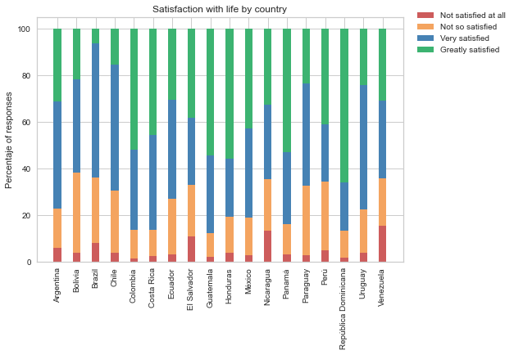

Figure 7 Shares of responses regarding satisfaction with life by country.

Moving to the analysis of variance. The following figures and tables show analysis of variance for the three indicators of interest. Figures 8, 9, and 10 show boxplots of the indicators grouped by clusters; tables 4.1, 5.1, and 6.1 show the results of the ANCOVA analysis, which attempt to show if there is any statistically significant difference in the variances between clusters, which would derive from the problems that subregions in the clusters share; and tables 4.2, 5.2, and 6.2 show the results of Tukey’s range tests, which compare means of the indicators for all pairs of clusters, to determine which couple of clusters are significantly different so that we can say that their main problems make a difference in their performance in the indicators.

Through the boxplot of trust in the government we find that the lowest median level of trust in the government is from subregions in the cluster 8 (although with 2 outliers with a higher level than in other clusters), followed by clusters 7 and 4. Variance of the levels of trust in the government is lower in clusters 8 and 4. On the other hand, the cluster with the highest median score is the 5th.

To make sense of the data, remember that cluster 8 is formed by subregions where the most important problems are related to health difficulties and corruption or problems of politics, of which the majority were Brazilian states, except for two subregions that were Colombian departments. Meanwhile cluster 4 is made of subregions where the most important problems are economic / financial and scarcity of food, exclusive to Venezuelan provinces. On subregions in cluster 5, although for most the main problem is unemployment, their 2nd most important problem varies, mostly between crime / public safety, corruption, economic / financial problems, and problems about the political situation. This might suggest that as there are not some clear problems that are pervasive to these places, these problems do not have the same severity as for example, scarcity of food and health problems for subregions in cluster 4 and 8 respectively.

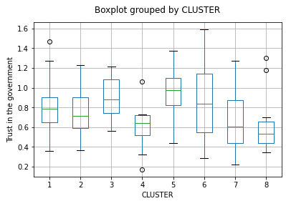

Figure 8 Boxplot of trust in the government by cluster.

With regards to the ANCOVA analysis, we are mainly interested in the significance of the variable CLUSTER. With an F score of 4.599 and p-value lower than 0.01 we can confidently say that there is a relationship between the cluster the subregion is part of and the degree of trust in the government of its citizens. Education is also significant while in this case there is no relationship between the socioeconomic status of the average citizen and the level of trust in the government.

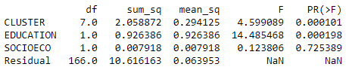

Table 4.1 Results of ANCOVA analysis for trust in the government.

Results of the Tukey’s range test for trust in the government show that it is only when classified in the cluster 4 that we can expect to see a difference in the degree of trust in the government of citizens, specifically when compared to clusters 3, 5, and 6. And there is also a significant difference between clusters 5 and 8.

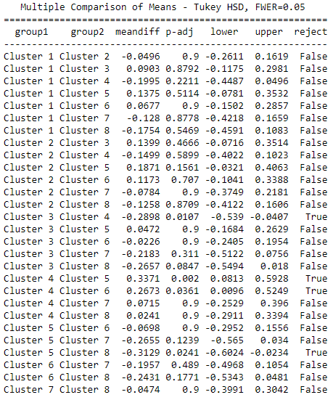

Table 4.2 Tukey's range test for trust in the government means between clusters.

Looking at differences in variances between levels of trust in the institutions (composite score calculated as the average between scores of trust in the government, trust in the congress, trust in the justice system, and trust in the police), figure 9 shows very similar results as for trust in the government alone, except for clearly much higher scores for cluster 8. In this case, cluster 8 has the highest median of trust in the institutions.

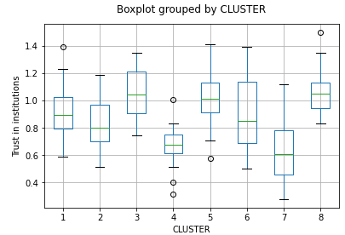

Figure 9 Boxplot of trust in the institutions by cluster.

For the ANCOVA analysis, with F score of 10.989 and a p-value lower than 0.05 again the problems in a subregion, as indicated by the cluster classification are statistically significant as a potential predictor of the level of trust in the institutions. In this case, the average socioeconomic status is statistically significant as well.

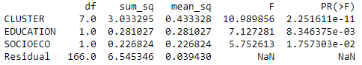

Table 5.1 Results of ANCOVA analysis for trust in the institutions.

There are more clear differences between clusters with respect to this indicator. Having the lowest average values of trust in the institutions, clusters 4 and 7 are significantly different from clusters 1, 3, 5, 6, and 8; on the other hand, cluster 2 is significantly different from clusters 3, 5, and 8.

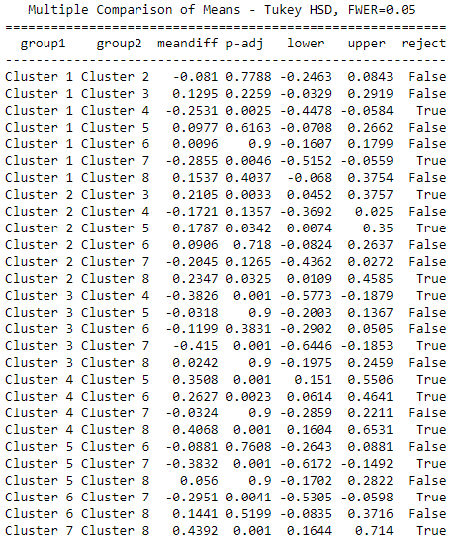

Table 5.2 Tukey's range test for trust in the institutions means between clusters.

Finally, with respect to satisfaction with life, lowest levels are reported in subregions of cluster 8, except for 2 departments in Colombia, similarly to levels of trust in the government. Second lowest median level of satisfaction with life is reported by subregions in cluster 4, which is exclusive to states of Venezuela. On the other hand, the highest median level of satisfaction with life is in cluster 2, followed by cluster 3.

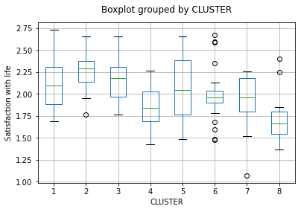

Figure 10 Boxplot of satisfaction with life by cluster.

The ANCOVA analysis results indicate that as expected, the cluster classification and the two covariates are statistically significant at predicting the levels of satisfaction with life of citizens in the clusters.

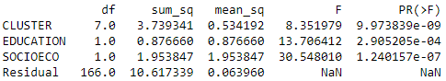

Table 6.1 Results of ANCOVA analysis for satisfaction with life.

Comparing satisfaction with life in pairs of clusters results are similar as with levels of trust in the government and institutions. Cluster 4 is significantly different from cluster 1, 2, and 3; satisfaction with life in cluster 8, which is the lowest in median, is different from cluster 1, 2, 3, and 5; besides clusters 4 and 8, cluster 2 is significantly different from clusters 6 and 7.

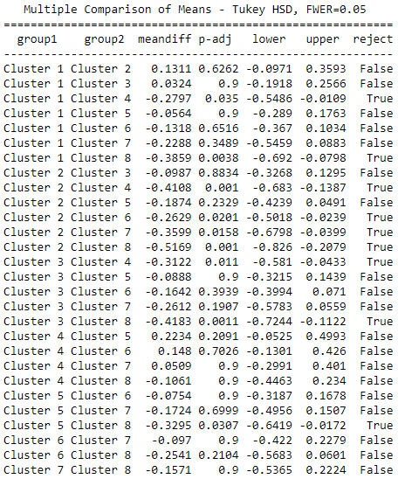

Table 6.2 Tukey's range test for satisfaction with life means between clusters.

Summarizing, by looking at the differences of the indicators of trust in the government, trust in the institutions and satisfaction with life, we can say that in the three measures, cluster 4, which is directly associated to states of Venezuela, presents the lowest performance. This cluster is characterized for the problems of scarcity of food and economic / financial problems. On trust in the institutions, cluster 7, associated directly with departments of Nicaragua, is the lowest performing compared to most groups. On satisfaction with life, cluster 8, which is mostly associated to states of Brazil and with problems related to health, corruption, and problems of politics, is the lowest performing; cluster 2 instead, presents the highest median, specially when compared to clusters 4, 6, 7, and 8.

**Conclusion**

Throughout these pages we looked at the different perceptions of Latin American citizens on what are the most important problems in their countries. As expected, similar to how there are many shared cultural, historic, and economic characteristics in Latin American social groups, there are also problems that are very common across the region.

That is the case, specially, of crime / public safety, which in 13 of the 18 countries of the study is among the top 3 most important problems, and in almost a third of the 176 subregions of the study is considered the most important problem, and the second most important problem in other 28 subregions. Other problems of great relevance in most Latin American countries were economic / financial problems and unemployment. For more specific cases but still very significant we find corruption and problems related to the political situation.

There are also cases of countries with situations that are unique, where citizens in many of their subregions bring the attention to problems that are not so spread in other countries of the region. The clearest example is Venezuela, where the most important problems are financial and of more interest, scarcity of food, an issue that was not among the most relevant in any other place of the region. Another region with a unique situation, signaled by a cluster exclusive to it, is Nicaragua. This is the only country where problems about politic were the most important, followed by unemployment and financial problems.

Looking at how clusters differ in the degree of trust in the government, trust in the institutions, and satisfaction with life of their citizens, ANCOVA analysis confirmed that there are significant differences, although only in specific cases. The cluster associated to Venezuelan states had some of the lowest values of all in the three measures, and there was a significant difference in scores of subregions of this cluster when compared with other clusters. On trust in the institutions, the cluster associated to Nicaragua also exhibited lower scores when compared with most other clusters, except when compared to the cluster for Venezuelan provinces and with the cluster 2, made of subregions that have crime / public safety and corruption, financial problems or problems of politics as the most important ones. On the other hand, in the case of satisfaction with life, besides Venezuela, a cluster of subregions where problems of health are the most important, showed the lowest scores.

For any policymakers, institutions, or any agent with the interest and capacity to intervene in some of the places of the study, these findings might be of great interest as they provide a starting point for the kind of plans that have to be taken. This information should contribute to the preparation of action plans, in ways such as helping to determine where actions are needed, what problems people believe are the most critical, or pointing out which subregions have similar problems so that the agents responsible in these places can think about cooperation to solve their issues.

1. In this study, subregion will refer to subnational divisions such as provinces, states, departments, etc., which are denominated differently in each country.